DESCRIPTIVE ANALYTICS II
Business Intelligence and Data Warehousing

1. Business Analytics Overview

1.1 What is Business Analytics?
Business analytics is the process of using data, statistical analysis, and quantitative methods to help organizations make better decisions. It covers a wide range of tools and techniques that transform raw data into meaningful insights.
Business analytics is divided into three main types, arranged from basic to advanced:

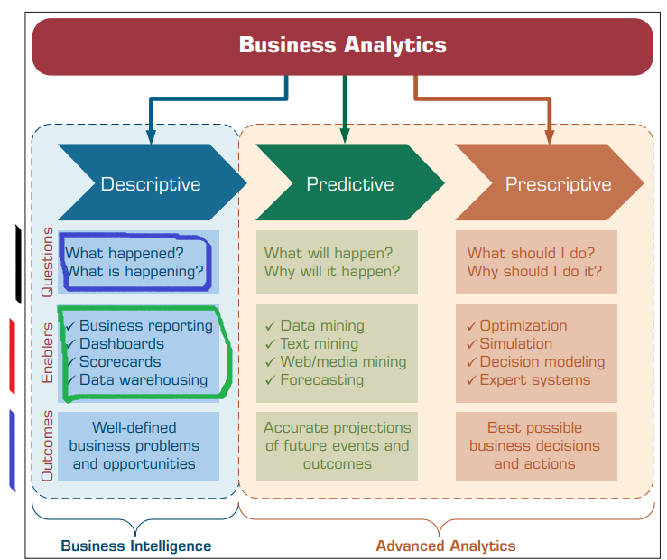
Figure 1: Business Analytics Taxonomy — Descriptive, Predictive, and Prescriptive Analytics

1.2 Types of Analytics

1.2.1 Descriptive Analytics
Descriptive analytics is the first and most basic level of analytics. It answers two key questions:
- What happened? — Looks at past events and historical data.
- What is happening? — Monitors current business activities in real time.
Tools and techniques include: Business reporting, Dashboards, Scorecards, Data warehousing.
Outcome: Identifies well-defined business problems and opportunities.
📌 Business Intelligence (BI) is part of Descriptive Analytics. It is also called business reporting.

1.2.2 Predictive Analytics
Predictive analytics answers: What will happen? and Why will it happen? It uses historical patterns to forecast future events.
- Techniques: Data mining, Text mining, Web/media mining, Forecasting.
- Outcome: Accurate projections of future events and outcomes.

1.2.3 Prescriptive Analytics
Prescriptive analytics is the most advanced level. It answers: What should I do? and Why should I do it?
- Techniques: Optimization, Simulation, Decision modeling, Expert systems.
- Outcome: Best possible business decisions and actions.
Descriptive and Predictive analytics together are often called Business Intelligence (BI). Prescriptive analytics is part of Advanced Analytics.

2. Business Intelligence (BI)

2.1 Definition
Business Intelligence (BI) is the entry-level type of business analytics. It is often called business reporting because most activities at this level deal with creating reports to summarize business activities.
Business Intelligence (BI): A set of processes, technologies, and tools used to collect, integrate, analyze, and present business information to support better decision making.

2.2 Purpose of Business Intelligence
- Summarize business activities for managers and executives.
- Provide insights about what happened and what is currently happening.
- Support knowledge workers (decision makers) with timely information.
- Enable quick, accurate, and data-driven decisions.

2.3 Why Organizations Need BI
- Large amounts of data are produced daily — BI helps make sense of it.
- Decision makers need fast, reliable information, not raw data.
- BI removes guesswork from business strategy.
- It tracks performance against goals (KPIs — Key Performance Indicators).
- BI helps identify trends, risks, and opportunities early.

2.4 Questions Answered by BI

What Happened?
This question looks backward at past events. For example, a retail store might ask: What were our total sales last month? BI generates historical reports and summaries to answer this.

What is Happening?
This question focuses on the present. For example: How many customers are visiting our website right now? BI uses dashboards and real-time monitoring tools to answer this.
📌 These two questions make BI the foundation of all analytics. You must understand the past and present before predicting or prescribing the future.

2.5 Types of BI Reporting

2.5.1 Static Reporting
Static reports are pre-built reports delivered to decision makers on a fixed schedule.
- Delivered at regular intervals: daily, weekly, monthly, quarterly.
- Also called scheduled reports or snapshot reports.
- Example: A weekly sales summary email sent every Monday morning.
- Example: A monthly profit/loss report generated automatically.
- Advantage: Consistent and reliable. Everyone sees the same data.
- Limitation: Not flexible — cannot be customized by users.

2.5.2 Ad-Hoc Reporting
Ad-hoc reporting allows users to create their own custom reports as needed, without involving IT departments.
- Users can build reports using intuitive drag-and-drop graphical interfaces.
- Designed for specific or unique decision situations.
- Example: A sales manager creates a report comparing sales of Product A vs Product B in Region 3 for a specific month.
- Advantage: Flexible and user-driven.
- Tools: Microsoft Power BI, Tableau, SAP BusinessObjects.

2.5.3 Dashboards
A dashboard is a visual display of Key Performance Indicators (KPIs) and important metrics, updated in real time or near-real time.
- Provides dynamic views of business performance.
- Designed for managers and executives for quick decision support.
- Presented in easy-to-read graphical formats: charts, graphs, gauges, maps.
- Example: A CEO dashboard showing daily revenue, customer satisfaction score, inventory levels, and website traffic — all in one screen.
- Advantage: Fast, visual, and actionable.

2.6 Business Intelligence Benefits
- Faster and better decision making based on real data.
- Identification of trends, patterns, and anomalies.
- Improved operational efficiency by highlighting bottlenecks.
- Better financial performance monitoring.
- Enhanced customer understanding and segmentation.
- Competitive advantage through data-driven strategies.
- Real-world example (Retail): A supermarket chain uses BI dashboards to track daily sales by store, identify low-stock items, and adjust promotions in real time.
- Real-world example (Banking): A bank uses BI reports to monitor daily transactions, detect fraud patterns, and track loan performance.

3. Relationship Between BI and Data Warehouse

3.1 Why BI Needs a Data Warehouse
BI systems do not work alone. They need a reliable, organized data source to generate accurate reports and insights. That source is the Data Warehouse.
As shown in the figure below, BI systems rely on a data warehouse as the information source for creating insight and supporting managerial decision making.

3.2 How BI and Data Warehouse Work Together
- The Data Warehouse collects, cleans, and stores large amounts of data from different sources.
- BI tools connect to the Data Warehouse to query and analyze data.
- Reports, dashboards, and analytics are generated for decision makers.
Think of the Data Warehouse as the engine room and BI as the dashboard that displays results.

3.3 Information Flow
Data Sources (ERP, CRM, POS, Web) → Data Warehouse → BI Tools → Reports & Dashboards → Decision Making
📌 The Data Warehouse is the foundation of BI. Without a well-structured data warehouse, BI cannot function effectively.
Aspect | Business Intelligence (BI) | Data Warehouse
Role | Analysis and reporting layer | Data storage and management layer
Function | Creates reports, dashboards, insights | Collects, stores, and organizes data
Users | Managers, executives, analysts | Data engineers, IT administrators
Output | Insights, decisions, KPIs | Organized, clean, historical data
Dependency | Depends on Data Warehouse | Independent storage system

4. Data Warehouse (DW)

4.1 Definition
In simple terms, a data warehouse (DW) is a pool of data produced to support decision making. It is also a repository of current and historical data of potential interest to managers throughout the organization.
Data Warehouse (DW): A subject-oriented, integrated, time-variant, and nonvolatile collection of data in support of management decision making.
📌 This definition was given by William Inmon, who is known as the 'Father of Data Warehousing.'

4.2 Purpose
- Store large volumes of current and historical data from across the organization.
- Provide data in a format ready for analytical processing.
- Support Online Analytical Processing (OLAP), data mining, querying, and reporting.
- Help managers and executives make better medium and long-term decisions.

4.3 Historical Context

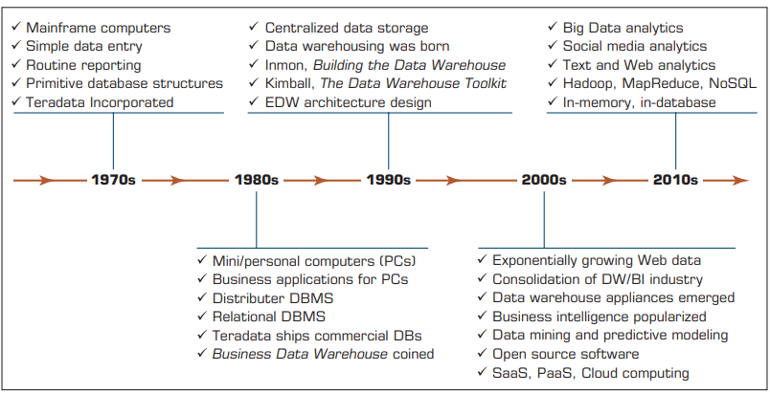
Figure 2: Evolution of Data Warehousing — from 1970s Mainframes to 2010s Cloud Computing

- 1970s: Mainframe computers, simple data entry, routine reporting, primitive database structures.
- 1980s: Mini/personal computers emerged, relational DBMS developed, Business Data Warehouse concept coined.
- 1990s: Centralized data storage, data warehousing born, Inmon published Building the Data Warehouse, EDW architecture designed.
- 2000s: Exponentially growing web data, consolidation of DW/BI industry, data mining and predictive modeling popularized.
- 2010s: Big Data analytics, social media analytics, Hadoop/MapReduce/NoSQL, in-memory computing, SaaS/PaaS/Cloud solutions.

5. Characteristics of a Data Warehouse

The four classic characteristics of a data warehouse are: Subject-Oriented, Integrated, Time-Variant, and Nonvolatile.

5.1 Subject-Oriented
Data in a data warehouse is organized around major subjects of the business, rather than around specific applications or processes.
- Focus is on key business areas: Sales, Products, Customers, Inventory.
- Example (Sales): All sales data from different regions, stores, and channels are stored together under the Sales subject.
- Example (Customer): All customer information — from CRM, billing, and support — is consolidated under Customer.
- Example (Product): Product data from manufacturing, marketing, and sales is stored under Product.
- This makes it easy for analysts to study a specific business area without switching between different systems.
📌 In operational databases, data is organized by application (e.g., the billing system has billing data). In a DW, data is organized by subject (e.g., the Customer subject has all customer-related data from all systems).

5.2 Integrated
A data warehouse must combine data from many different sources into one consistent format. This is called data integration.
- Data comes from multiple source systems: ERP, CRM, POS terminals, web applications, spreadsheets.
- Each source system may store data differently — this creates conflicts.
- Naming conflicts: One system calls it 'gender' as M/F, another as Male/Female.
- Unit conflicts: One system stores weight in kilograms, another in pounds.
- The data warehouse resolves all these conflicts and provides a single, consistent version of data.
Real-world example (E-Commerce): A company has separate systems for website orders, mobile app orders, and in-store sales. The data warehouse integrates all three into one unified dataset.

5.3 Time-Variant (Time Series)
A data warehouse stores historical data over time. This is different from operational databases which typically show only the current state.
- Historical data helps detect trends, deviations, and long-term relationships.
- Used for forecasting and comparisons (this year vs last year).
- Every record in a data warehouse has a time dimension (date/time stamp).
- Typical data warehouse stores 5 to 10 years of historical data.
- Example (Retail): A retailer stores 10 years of sales data to identify seasonal trends and plan inventory for upcoming holidays.
- Example (Banking): A bank stores 7 years of transaction history to analyze customer spending patterns.
📌 Operational databases only keep current data. Data warehouses keep historical data to support trend analysis.

5.4 Nonvolatile
Data in a data warehouse is stable. Once data is loaded into the warehouse, it cannot be changed or deleted by regular users.
- Data is read-only for end users.
- No frequent updates or modifications happen.
- The only operations are: Load (initial data entry) and Access (querying/reading data).
- This ensures data integrity and consistency for analysis.
- Example: If a customer placed an order last year, that historical record stays unchanged even if the customer updates their address today.

6. Additional Characteristics of a Data Warehouse

6.1 Web-Based
Modern data warehouses are designed to provide efficient computing environments for Web-based applications. Users can access reports and dashboards through web browsers without installing software.

6.2 Relational Structure
A relational data warehouse stores data in tables (rows and columns) following the relational model. It uses SQL (Structured Query Language) for querying. This is the traditional and widely used approach.

6.3 Multidimensional Structure
Some data warehouses use a multidimensional structure (also called OLAP cubes). Data is organized in dimensions (like time, geography, product) and measures (like sales, profit). This allows faster analytical queries and slice-and-dice analysis.

6.4 Client-Server Architecture
Data warehouses use client-server architecture. The server stores and processes data. Clients (user computers, browsers) send queries and receive results. This provides easy access for end users across the organization.

6.5 Real-Time Data Warehousing
Newer data warehouses provide real-time or active data access and analysis. This is sometimes called active data warehousing. It allows organizations to make decisions based on data that is only seconds or minutes old.

6.6 Metadata
Metadata: Data about data. Metadata describes how data is organized and how to effectively use it.
- Metadata tells users: What data is available? Where it comes from? How it was transformed? When it was last updated?
- Example: A table called 'Sales_2024' — metadata would tell you: it contains sales transactions from January to December 2024, sourced from the ERP system, updated every night at 2:00 AM.
- Metadata is critical for data governance, documentation, and auditing.
- Without metadata, users cannot trust or understand the data in the warehouse.

7. Data Mart (DM)

7.1 Definition
Data Mart (DM): A small, focused subset of a data warehouse that stores data for a specific department or business area.
While a data warehouse combines databases across an entire enterprise, a data mart is usually smaller and focuses on a particular subject or department.
- Typical data mart covers one subject area: Marketing, Finance, Operations, HR.
- Size: Much smaller than a full data warehouse.
- Purpose: Provides department-specific data faster and more efficiently.

7.2 Purpose
- Serve the specific needs of a single department.
- Improve query performance for departmental users.
- Reduce complexity — users only see data relevant to them.
- Example (Healthcare): A hospital's Finance department has a data mart with billing, insurance claims, and cost data — without seeing clinical or HR data.

7.3 Data Warehouse vs Data Mart

Aspect | Data Warehouse | Data Mart
Scope | Enterprise-wide (entire organization) | Department-specific (one subject area)
Size | Very large (terabytes to petabytes) | Smaller (gigabytes to terabytes)
Users | All departments across the organization | Specific department or business unit
Data | All organizational data integrated | Subset of DW data for one area
Cost | High — complex and expensive | Lower — simpler and cheaper
Time to Build | Months to years | Weeks to months
Example | Enterprise-wide sales + HR + finance + ops | Marketing department analytics only

8. Types of Data Mart

8.1 Dependent Data Mart
A dependent data mart is a subset that is created directly from the enterprise data warehouse (EDW).
- Data source: Enterprise Data Warehouse (EDW).
- The EDW must be built first before a dependent DM can be created.
- Advantages:
  - Consistent data model — all data marts share the same enterprise data standards.
  - High data quality — data has already been cleaned and integrated in the EDW.
  - Ensures all users see the same version of data as other DW users.
  - Supports the concept of a single enterprise-wide data model.
- Limitation: Requires significant upfront investment to build the EDW first.
📌 Real-world example: A large retail chain builds an EDW with all company data, then creates dependent data marts for Marketing, Finance, and Supply Chain departments.

8.2 Independent Data Mart
An independent data mart is a small warehouse designed for a strategic business unit or department, but its data source is NOT an enterprise data warehouse.
- Data source: Directly from operational source systems (ERP, CRM, spreadsheets).
- No central EDW is required.
- Advantages:
  - Faster and cheaper to build — no EDW needed.
  - Good for small businesses or departments that need quick analytics.
- Limitations:
  - Data may be inconsistent across different departments.
  - No single version of truth — different DMs may show different numbers.
  - Difficult to scale into an enterprise-wide solution.
📌 Real-world example: A startup company's Marketing team builds an independent data mart pulling directly from their CRM system, before the company has built a full enterprise data warehouse.

8.3 Dependent vs Independent Data Mart — Comparison

Aspect | Dependent Data Mart | Independent Data Mart
Data Source | Enterprise Data Warehouse (EDW) | Directly from source systems (no EDW)
Cost | Higher (EDW must be built first) | Lower (can be built independently)
Consistency | High — uses standardized EDW data | Lower — data may conflict with other DMs
Data Quality | High — data is pre-cleaned in EDW | Varies — depends on source system quality
Scalability | Highly scalable at enterprise level | Limited — harder to expand
Enterprise Integration | Fully integrated with enterprise data | Not integrated — operates in isolation
Build Time | Longer (EDW needed first) | Shorter (quick deployment)
Best For | Large enterprises with an EDW | Small departments or startups

9. Operational Data Store (ODS)

9.1 Definition
Operational Data Store (ODS): A database used as an interim staging area for a data warehouse, containing near-real-time, current, and frequently updated data from multiple source systems.

9.2 Purpose
- Provide a near-real-time, integrated view of current operational data.
- Support short-term, mission-critical operational decisions.
- Act as a staging area before data is moved into the permanent data warehouse.
- Consolidate data from multiple source systems into one accessible location.

9.3 Characteristics of ODS
- Frequently Updated: Unlike a data warehouse, the ODS is updated throughout the day as business operations occur.
- Current Information: Stores only very recent data — hours or days old, not years.
- Volatile Data: Data in ODS can change. Old data is overwritten by new data.
- Mission-Critical Applications: Used for day-to-day operational decisions that need current information.
- Near-Real-Time: Provides data that is close to real-time (minutes or hours old).

9.4 The Short-Term vs Long-Term Memory Analogy
This is a very important analogy from the textbook:
ODS = Short-Term Memory | Data Warehouse = Long-Term Memory
- Stores only very recent information  - Data is volatile (changes frequently)  - Used for immediate decisions  - Like human working memory | - Stores permanent historical information  - Data is stable (nonvolatile)  - Used for strategic decisions  - Like human long-term memory

9.5 ODS vs Data Warehouse — Comparison

Aspect | ODS | Data Warehouse
Purpose | Short-term operational decisions | Medium/long-term strategic decisions
Data Freshness | Near-real-time (minutes/hours old) | Historical (days to years old)
Data Type | Current, volatile, frequently changing | Stable, nonvolatile, historical
Update Frequency | Continuously updated (real-time) | Batch updates (daily, weekly)
Time Horizon | Very recent data only | 5-10 years of historical data
Decision Support | Tactical, operational decisions | Strategic, analytical decisions
Example Use | Check if a customer's order is in stock now | Analyze 5-year sales trend by region
Analogy | Short-term memory | Long-term memory

10. Enterprise Data Warehouse (EDW)

10.1 Definition
Enterprise Data Warehouse (EDW): A large-scale data warehouse used across the entire enterprise for decision support, integrating data from many sources into a standard format.
An EDW is the highest level of data warehouse. It covers the entire organization and serves as the central data repository for all departments.

10.2 Why Organizations Use EDW
- Standardized Data: All departments use the same data definitions and formats.
- Centralized Repository: Single source of truth for the entire organization.
- Better Decision Making: Executives and managers get a complete view of the business.
- Scalability: Can handle massive volumes of data across all business units.
- Integration: Connects all departments — Finance, Marketing, HR, Operations.

10.3 Applications of EDW

Customer Relationship Management (CRM)
EDW stores all customer interaction data — purchases, complaints, inquiries, demographics. This helps companies understand customers better, personalize offers, and improve loyalty.
Real-world example: A bank uses EDW-powered CRM to identify high-value customers and offer them premium services.

Supply Chain Management (SCM)
EDW tracks the flow of goods, materials, and information from suppliers to customers. It helps optimize inventory levels, reduce costs, and improve delivery performance.
Real-world example (Manufacturing): An automobile company uses EDW to track parts from 500 suppliers globally and predict shortages before they happen.

Business Performance Management (BPM)
BPM uses EDW data to track how well the organization is performing against its strategic goals. It includes budgeting, forecasting, and performance scorecards.
Real-world example: A telecom company tracks monthly KPIs (revenue per user, churn rate, network uptime) using BPM dashboards powered by EDW.

Business Activity Monitoring
Monitors business processes in real time and alerts managers when something deviates from normal. EDW provides the historical baseline to define what is normal.
Real-world example (E-Commerce): An online store uses business activity monitoring to detect a sudden drop in checkout completions and alert the IT team immediately.

Product Lifecycle Management
Tracks a product from concept, design, manufacturing, sales, to retirement. EDW integrates data from R&D, engineering, manufacturing, and sales.
Real-world example: A pharmaceutical company uses EDW to track drug development from research through clinical trials to market sales.

Revenue Management
Helps organizations optimize pricing and maximize revenue. Uses historical sales, demand, and pricing data stored in EDW.
Real-world example (Healthcare): A hospital uses revenue management systems connected to EDW to optimize bed pricing, staff allocation, and billing cycles.

Knowledge Management
Captures, organizes, and makes available the organization's knowledge — best practices, lessons learned, expert knowledge. Sometimes connected to EDW for analytical purposes.

11. Data Warehouse Framework and Architecture

11.1 Data Warehouse Framework
The data warehouse framework shows how data flows from its original sources all the way to the final reports and decisions made by users.

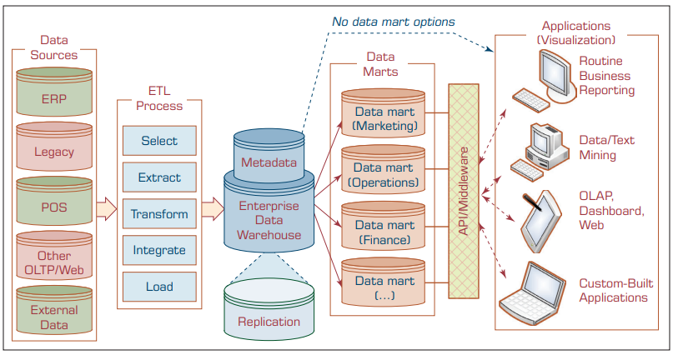
Figure 3: Data Warehouse Framework — ETL Process, EDW, Data Marts, and Applications

11.2 Step-by-Step Flow Explanation

Step 1: Data Sources
Data enters the warehouse from multiple operational source systems:
- ERP (Enterprise Resource Planning): Core business data — finance, HR, inventory.
- Legacy Systems: Older mainframe-based applications still in use.
- POS (Point of Sale): Retail transaction data from stores.
- Other OLTP/Web Systems: Online transaction processing systems and web platforms.
- External Data: Third-party data sources — market research, demographics, social media.

Step 2: ETL Process (Extract, Transform, Load)
ETL is the critical process that prepares data for the warehouse:
- Select: Choose which data to extract from source systems.
- Extract: Pull raw data from source systems.
- Transform: Clean, standardize, and integrate data — resolve naming conflicts, fix errors, unify formats.
- Integrate: Merge data from different sources into a consistent structure.
- Load: Insert the transformed data into the Enterprise Data Warehouse.

Step 3: Enterprise Data Warehouse (EDW) + Metadata
The EDW is the central storage layer. It contains the Metadata repository alongside the data. Metadata documents what data exists, where it came from, and how it was transformed.
Note: The framework also shows a Replication component — data can be replicated for backup or performance purposes.

Step 4: Data Marts
From the EDW, data flows into specialized Data Marts for individual departments:
- Data Mart (Marketing): Customer data, campaign performance, leads.
- Data Mart (Operations): Supply chain, inventory, production data.
- Data Mart (Finance): Budget, expenses, revenue, profit data.
- Data Mart (...): Any additional department-specific mart.
Note: The dashed line in the diagram labeled 'No data mart options' shows that some applications can connect directly to the EDW without needing a data mart.

Step 5: API/Middleware
The API/Middleware layer connects the data marts (and EDW) to end-user applications. It handles data translation, security, and access management.

Step 6: Applications (Visualization)
End users access data through various application types:
- Routine Business Reporting: Standard scheduled reports.
- Data/Text Mining: Advanced analytics to find patterns.
- OLAP, Dashboard, Web: Interactive analytical tools and dashboards.
- Custom-Built Applications: Tailored solutions for specific business needs.

11.3 Architecture and Workflow Summary

Layer | Component | Purpose
1. Source Layer | ERP, Legacy, POS, Web, External | Original data production systems
2. Integration Layer | ETL (Select, Extract, Transform, Load) | Data cleaning, transformation, loading
3. Storage Layer | Enterprise Data Warehouse + Metadata | Central organized data repository
4. Distribution Layer | Data Marts (per department) | Departmental subsets for fast access
5. Access Layer | API / Middleware | Connects data to applications securely
6. Presentation Layer | Reports, Dashboards, OLAP, Mining Apps | End-user analysis and visualization
7. Decision Layer | Managers, Executives, Analysts | Business decisions based on insights

12. Master Comparison Tables

12.1 ODS vs EDW

Aspect | ODS | EDW
Scope | Current operational data only | Enterprise-wide, all historical data
Purpose | Short-term operational support | Long-term strategic decision support
Data Age | Near real-time (hours) | Historical (years)
Volatility | High (frequently updated) | Low (nonvolatile)
Users | Operations staff, front-line managers | Executives, analysts, BI users
Size | Smaller | Very large
Decision Type | Tactical, mission-critical | Strategic, analytical

12.2 Full Summary: All Key Comparisons

Feature | Data Warehouse | Data Mart | ODS | EDW
Scope | Organization-wide | Department-only | Current operations | Entire enterprise
Data Age | Historical | Historical subset | Near-real-time | Historical + recent
Update Frequency | Batch (daily/weekly) | Batch (daily/weekly) | Continuous (real-time) | Batch (regular)
Volatility | Nonvolatile | Nonvolatile | Volatile | Nonvolatile
Size | Large | Small to medium | Medium | Very large
Primary Use | Analytics & reporting | Dept analytics | Operational decisions | Enterprise BI & DSS
Cost | High | Medium | Medium | Very high
Users | All departments | One department | Operations team | Entire enterprise

13. Exam Revision Section

13.1 Key Definitions to Memorize
Business Intelligence (BI): Entry-level analytics; creates reports and dashboards to answer 'What happened?' and 'What is happening?'
Data Warehouse (DW): A subject-oriented, integrated, time-variant, nonvolatile collection of data for decision support.
Data Mart (DM): A smaller, department-focused subset of a data warehouse.
Dependent Data Mart: Created directly from an EDW; consistent and high quality.
Independent Data Mart: Created directly from source systems; no EDW needed; less consistent.
ODS (Operational Data Store): Near-real-time database for short-term operational decisions; volatile data.
EDW (Enterprise Data Warehouse): Large-scale, organization-wide data warehouse for all enterprise decision support.
ETL: Extract, Transform, Load — the process of moving data into a data warehouse.
Metadata: Data about data — describes what data exists, where it came from, and how it was transformed.
OLAP: Online Analytical Processing — used for complex analytical queries on a data warehouse.

13.2 Important Characteristics

Four Core DW Characteristics
Characteristic | Meaning | Key Point
Subject-Oriented | Organized by business subject (Sales, Customer, Product) | Focused on decision-relevant topics
Integrated | Data from multiple sources unified into one consistent format | Resolves naming and unit conflicts
Time-Variant | Stores historical data with time stamps | Supports trend analysis and forecasting
Nonvolatile | Data is read-only; cannot be changed after loading | Ensures stable data for analysis

13.3 Frequently Asked Exam Questions
- What is Business Intelligence? How is it different from Advanced Analytics?
Answer: BI is descriptive analytics — it uses data warehouses to answer 'what happened' and 'what is happening' through reports and dashboards. Advanced Analytics includes predictive and prescriptive analytics that use techniques like data mining, optimization, and AI.

- Define Data Warehouse. Explain its four main characteristics.
Answer: A DW is a subject-oriented, integrated, time-variant, and nonvolatile collection of data for decision support. [Explain each characteristic — see Section 5.]

- What is the difference between a Data Warehouse and a Data Mart?
Answer: A DW covers the entire enterprise; a DM is a smaller, department-specific subset. A DW is the source for dependent DMs.

- Compare Dependent vs Independent Data Mart.
Answer: Dependent DM is created from an EDW — consistent and high quality. Independent DM is created directly from source systems — faster to build but less consistent.

- What is an ODS? How is it different from a Data Warehouse?
Answer: ODS is a near-real-time staging area for current operational data. DW is for historical strategic data. ODS = short-term memory; DW = long-term memory.

- What is an EDW? List five applications of EDW.
Answer: EDW is a large-scale enterprise-wide data warehouse. Applications: CRM, SCM, BPM, Business Activity Monitoring, Product Lifecycle Management, Revenue Management, Knowledge Management.

- Explain the ETL process.
Answer: ETL = Extract, Transform, Load. Extract: Pull data from source systems. Transform: Clean, standardize, integrate data. Load: Insert into the data warehouse.

13.4 Viva Questions with Short Answers
Viva Question | Short Answer
What does BI stand for? | Business Intelligence
Who is the 'Father of Data Warehousing'? | William Inmon
What are the 4 classic DW characteristics? | Subject-oriented, Integrated, Time-variant, Nonvolatile
What does nonvolatile mean in a DW? | Data is read-only; users cannot change it after it is loaded
What is metadata? | Data about data — describes how data is organized and how to use it
What is ETL? | Extract, Transform, Load — process of moving data into a DW
What does ODS stand for? | Operational Data Store
What is ODS like in human memory analogy? | Short-term memory (stores only recent info)
What is DW like in human memory analogy? | Long-term memory (stores permanent historical info)
What does EDW stand for? | Enterprise Data Warehouse
Name 3 BI report types | Static Reports, Ad-Hoc Reports, Dashboards
What is a Data Mart? | A small, department-specific subset of a data warehouse
What is a dependent DM? | A DM created from an existing EDW
What is an independent DM? | A DM created directly from source systems (no EDW)
What does OLAP stand for? | Online Analytical Processing
What questions does BI answer? | What happened? and What is happening?
What is a dashboard? | A visual display of KPIs for real-time decision support
Give 2 EDW applications | CRM and Supply Chain Management (SCM)
What is the purpose of an ODS? | Near-real-time operational decisions; staging for DW
Name the layers in the DW framework | Sources → ETL → EDW → Data Marts → Middleware → Applications

13.5 One-Page Revision Summary

ONE-PAGE REVISION SUMMARY: BI & Data Warehousing
Analytics Types  - Descriptive = BI (What happened? / happening?)  - Predictive (What will happen?)  - Prescriptive (What should I do?) | BI Report Types  - Static Reports (scheduled, fixed)  - Ad-Hoc Reports (user-created, flexible)  - Dashboards (KPIs, real-time, visual)
DW 4 Characteristics  - Subject-Oriented (by business topic)  - Integrated (unified from multiple sources)  - Time-Variant (historical, time-stamped)  - Nonvolatile (read-only, stable) | Key Analogies & Mnemonics  - ODS = Short-Term Memory  - DW = Long-Term Memory  - ETL = Extract, Transform, Load  - SITN = Subject, Integrated, Time, Nonvolatile
DW Framework Flow (must memorize)
Source Systems → ETL (Select/Extract/Transform/Integrate/Load) → EDW + Metadata → Data Marts → API/Middleware → BI Applications → Decisions

End of Study Notes
Descriptive Analytics II: Business Intelligence and Data Warehousing

